### Q1.

## a.

# Monthly total bill of all three stores

df <- read.csv("Coffee_Shop_Data_cleaned.csv")

library(dplyr)

##   
## 载入程辑包：'dplyr'

## The following objects are masked from 'package:stats':  
##   
## filter, lag

## The following objects are masked from 'package:base':  
##   
## intersect, setdiff, setequal, union

monthly_total_bill <- df %>%  
 group_by(Month) %>%  
 summarise(Total_Bill = sum(Total_Bill))  
  
library(ggplot2)  
ggplot(monthly_total_bill, aes(x = Month, y = Total_Bill)) +  
 geom_line(color = "steelblue") +   
 labs(x = "Month", y = "Total Bill", title = "Monthly Total Bill") +  
 scale_x_continuous(breaks = 1:12, labels = c("Jan", "Feb", "Mar", "Apr", "May", "Jun",  
 "Jul", "Aug", "Sep", "Oct", "Nov", "Dec")) +  
 theme_minimal()

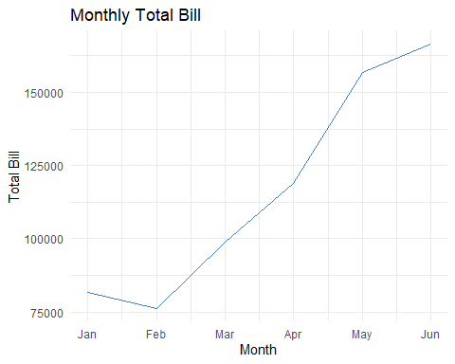

# Monthly total bills of Tea of store 3

Tea_3_df <- subset(df, product_category == "Tea" & store_id == 3)  
  
library(dplyr)  
monthly_total_bill <- Tea_3_df %>%  
 group_by(Month) %>%  
 summarise(Total_Bill = sum(Total_Bill))  
  
library(ggplot2)  
ggplot(monthly_total_bill, aes(x = Month, y = Total_Bill)) +  
 geom_line(color = "steelblue") +   
 labs(x = "Month", y = "Total Bill", title = "Store 3 Monthly Total Bill of Tea") +  
 scale_x_continuous(breaks = 1:12, labels = c("Jan", "Feb", "Mar", "Apr", "May", "Jun",  
 "Jul", "Aug", "Sep", "Oct", "Nov", "Dec")) +  
 theme_minimal()

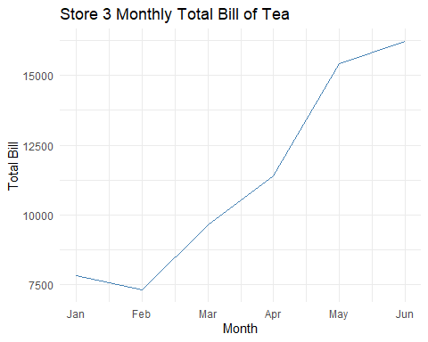 # Monthly total bills of of store 3

store_3_df <- subset(df, store_id == 3)  
  
library(dplyr)  
monthly_total_bill <- store_3_df %>%  
 group_by(Month) %>%  
 summarise(Total_Bill = sum(Total_Bill))  
  
library(ggplot2)  
ggplot(monthly_total_bill, aes(x = Month, y = Total_Bill)) +  
 geom_line(color = "steelblue") +   
 labs(x = "Month", y = "Total Bill", title = "Store 3 Monthly Total Bill") +  
 scale_x_continuous(breaks = 1:12, labels = c("Jan", "Feb", "Mar", "Apr", "May", "Jun",  
 "Jul", "Aug", "Sep", "Oct", "Nov", "Dec")) +  
 theme_minimal()

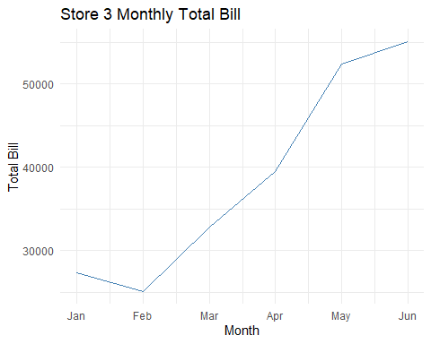

## b.

library(dplyr)  
sales_by_category <- df %>%  
 group_by(store_id, product_category) %>%  
 summarise(Total_Sales = sum(Total_Bill))

## `summarise()` has grouped output by 'store_id'. You can override using the  
## `.groups` argument.

library(ggplot2)  
ggplot(sales_by_category, aes(x = product_category, y = Total_Sales, fill = factor(store_id))) +  
 geom_bar(stat = "identity", position = "dodge") +  
 labs(x = "Product Category", y = "Total Sales", title = "Sales by Product Category for Stores 3, 5, and 8") +  
 scale_fill_discrete(name = "Store ID") +  
 theme_minimal() +  
 theme(axis.text.x = element_text(angle = 45, hjust = 1))

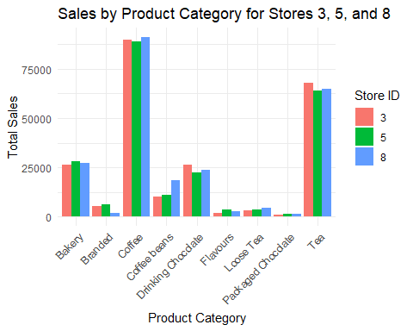

## c.

# line chart

library(dplyr)  
sales_by_hour <- df %>%  
 group_by(Hour) %>%  
 summarise(Total_Sales = sum(Total_Bill))  
  
library(ggplot2)  
ggplot(sales_by_hour, aes(x = Hour, y = Total_Sales)) +  
 geom_line(color = "steelblue", size = 1) +  
 geom_point(color = "steelblue", size = 3) +  
 labs(x = "Hour of the Day", y = "Total Sales", title = "Sales by Hour") +  
 scale_x_continuous(breaks = seq(0, 23, by = 1)) +  
 theme_minimal()

## Warning: Using `size` aesthetic for lines was deprecated in ggplot2 3.4.0.  
## ℹ Please use `linewidth` instead.  
## This warning is displayed once every 8 hours.  
## Call `lifecycle::last_lifecycle_warnings()` to see where this warning was  
## generated.

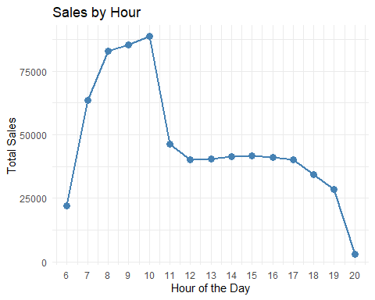 # heat map

library(ggplot2)  
ggplot(sales_by_hour, aes(x = factor(Hour), y = 1, fill = Total_Sales)) +  
 geom_tile(color = "white", size = 0.5) +  
 scale_fill_gradient(low = "white", high = "steelblue") +  
 labs(x = "Hour of the Day", y = "", title = "Sales by Hour") +  
 theme_minimal() +  
 theme(axis.text.y = element_blank(),  
 axis.ticks.y = element_blank(),  
 panel.grid = element_blank())

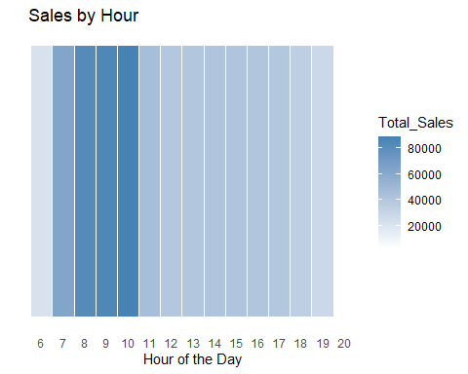 # lollipop chart

library(ggplot2)  
ggplot(sales_by_hour, aes(x = factor(Hour), y = Total_Sales)) +  
 geom_point(color = "steelblue", size = 4) +  
 geom_segment(aes(x = factor(Hour), xend = factor(Hour), y = 0, yend = Total_Sales), color = "steelblue") +  
 labs(x = "Hour of the Day", y = "Total Sales", title = "Sales by Hour") +  
 theme_minimal() +  
 theme(axis.text.x = element_text(angle = 45, hjust = 1))

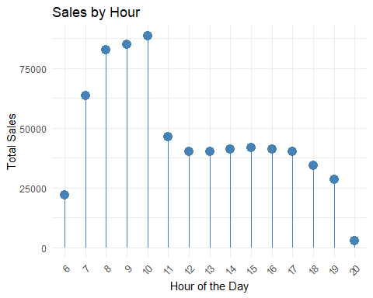

### Q2.

# install.packages("randomForest")  
library(randomForest)

## randomForest 4.7-1.1

## Type rfNews() to see new features/changes/bug fixes.

##   
## 载入程辑包：'randomForest'

## The following object is masked from 'package:ggplot2':  
##   
## margin

## The following object is masked from 'package:dplyr':  
##   
## combine

library(dplyr)

tea_sales <- df %>%  
 filter(product_category == "Tea") %>%  
 group_by(store_id, Day.of.Week, Hour) %>%  
 summarise(Total_Bill = sum(Total_Bill))

## `summarise()` has grouped output by 'store_id', 'Day.of.Week'. You can override  
## using the `.groups` argument.

set.seed(123)   
train_index <- sample(nrow(tea_sales), 0.7 * nrow(tea_sales))  
train_data <- tea_sales[train_index, ]  
test_data <- tea_sales[-train_index, ]

rf_model <- randomForest(Total_Bill ~ store_id + Day.of.Week + Hour,  
 data = train_data,  
 ntree = 500,  
 mtry = 2,  
 importance = TRUE)

# Make predictions on the test data  
predictions <- predict(rf_model, newdata = test_data)  
  
# Calculate the mean squared error (MSE)  
mse <- mean((test_data$Total_Bill - predictions)^2)  
print(paste0("Mean Squared Error (MSE): ", mse))

## [1] "Mean Squared Error (MSE): 8019.75246870488"

# Calculate the root mean squared error (RMSE)  
rmse <- sqrt(mse)  
print(paste0("Root Mean Squared Error (RMSE): ", rmse))

## [1] "Root Mean Squared Error (RMSE): 89.5530706827236"

# Calculate the R-squared (R^2)  
r_squared <- 1 - (sum((test_data$Total_Bill - predictions)^2) / sum((test_data$Total_Bill - mean(test_data$Total_Bill))^2))  
print(paste0("R-squared (R^2): ", r_squared))

## [1] "R-squared (R^2): 0.905851146727362"

importance_scores <- importance(rf_model)  
print(importance_scores)

## %IncMSE IncNodePurity  
## store_id 61.68627 2651828.2  
## Day.of.Week -11.06519 714362.8  
## Hour 102.86598 15624045.0

new_data <- data.frame(  
 store_id = c(3, 5, 8),  
 Day.of.Week = rep("Wednesday", 3),  
 Hour = rep(11, 3)  
)

predictions <- predict(rf_model, newdata = new_data)  
  
results <- data.frame(new_data, Total_Bill = predictions)  
print(results)

## store_id Day.of.Week Hour Total_Bill  
## 1 3 Wednesday 11 657.3200  
## 2 5 Wednesday 11 530.0715  
## 3 8 Wednesday 11 547.5709

### Extra Credit

new_data <- data.frame(  
 store_id = rep(3, 15),   
 Day.of.Week = rep(2,15),   
 Name.Day = ("Wednesday"),  
 product_catery = ("Tea"),  
 Hour = seq(6, 20)  
)

predictions <- predict(rf_model, newdata = new_data)  
results <- data.frame(new_data, Total_Bill = predictions)  
results

## store_id Day.of.Week Name.Day product_catery Hour Total_Bill  
## 1 3 2 Wednesday Tea 6 641.1136  
## 2 3 2 Wednesday Tea 7 814.7872  
## 3 3 2 Wednesday Tea 8 853.3714  
## 4 3 2 Wednesday Tea 9 943.6609  
## 5 3 2 Wednesday Tea 10 951.7408  
## 6 3 2 Wednesday Tea 11 664.2715  
## 7 3 2 Wednesday Tea 12 693.6467  
## 8 3 2 Wednesday Tea 13 690.5155  
## 9 3 2 Wednesday Tea 14 689.8835  
## 10 3 2 Wednesday Tea 15 700.4262  
## 11 3 2 Wednesday Tea 16 658.0419  
## 12 3 2 Wednesday Tea 17 667.8849  
## 13 3 2 Wednesday Tea 18 672.1328  
## 14 3 2 Wednesday Tea 19 697.2537  
## 15 3 2 Wednesday Tea 20 460.2027

library(ggplot2)  
# Line plot  
ggplot(results, aes(x = Hour, y = Total_Bill)) +  
 geom_line(color = "steelblue", size = 1) +  
 geom_point(color = "steelblue", size = 3) +  
 labs(x = "Hour of the Day", y = "Predicted Total Bill", title = "Predicted Sales of Tea Across Wednesday") +  
 scale_x_continuous(breaks = seq(0, 23, by = 1)) +  
 theme_minimal()

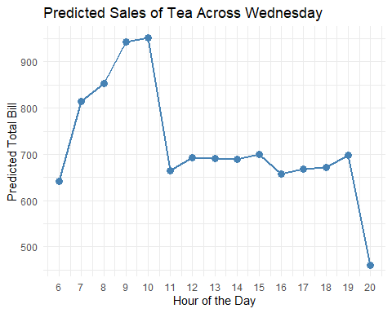

# Bar plot  
ggplot(results, aes(x = factor(Hour), y = Total_Bill)) +  
 geom_bar(stat = "identity", fill = "steelblue") +  
 labs(x = "Hour of the Day", y = "Predicted Total Bill", title = "Predicted Sales of Tea Across Wednesday") +  
 theme_minimal() +  
 theme(axis.text.x = element_text(angle = 45, hjust = 1))

